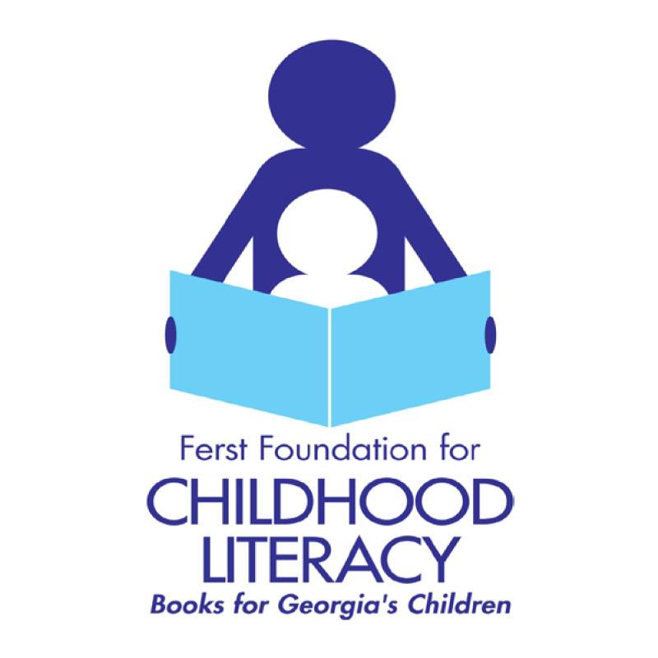

Ferst Foundation for Childhood Literacy Volunteer Application

Name:

Age:

Reason for volunteering:

Email address:

Phone number:

Preferred method of contact:

